Let’s Paint Math Task

You have a job to paint the office and the upstairs bedroom of a neighbor’s house. You ask your brother to help you. Yesterday you and your brother each painted a 12 ft x 15 ft wall in the office. It took you one hour to paint the wall and it took your brother 40 minutes to paint the same size wall. Today you and your brother will need to finish painting the office and upstairs bedroom.

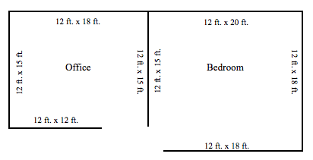

If you and your brother work together, how long will it take to finish painting both rooms?

Extension Question:
Your brother has to attend basketball practice this morning, so he will be one hour late to begin. If you start now and your brother joins you in two hours, how long will it take to paint the two rooms?

